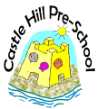
10.1 Early Years Prospectus

Policy Statement
This prospectus aims to provide you with an introduction to Castle Hill Pre-School, our routines, our approach to caring for your child and supporting their learning and development, and how we aim to work together with you to best meet your child’s individual needs. This should be read alongside our other policies and procedures for a full description of our services.

PLEASE SEE WELCOME PACK
(This is what we call our Early Years Prospectus).

